Northwest Career Academy

May 20th – 23rd, 2019

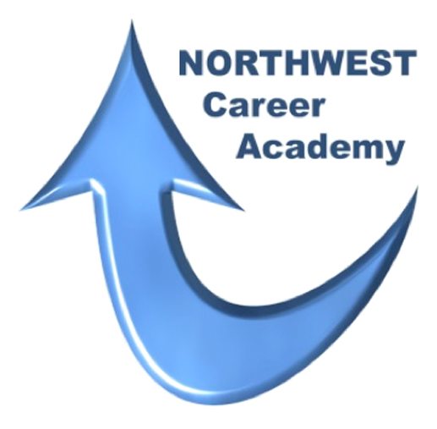

Program Application

Northwest Career Academy 2019

Program Application

Due on __ _______________________

Before applying, please review the session dates, May 20 – 23, 2019 and the participation
requirements on the following page. If you know that you will be unable to attend one or
more of the sessions, you need not apply.

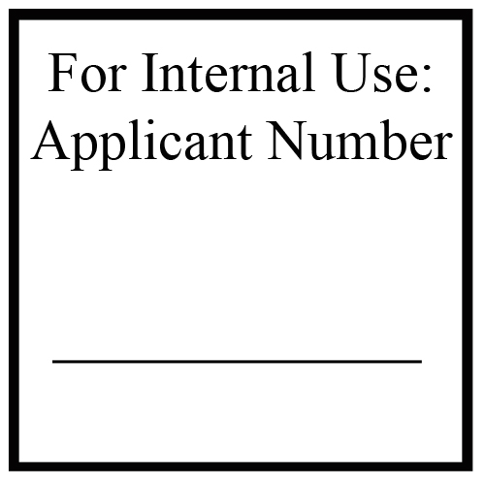
Applicants will be judged based on the following: application content and appearance,
variety and quality of activities and awards, and essay answers. Each applicant is awarded
points in each of these areas, the highest scoring applicants will be selected for an interview.
Interviews will be arranged through your school’s counseling office.

If additional space is required for your answers to the following sections, please attach
additional sheets as necessary. Please print in blue or black ink, or type application
If you would like to download an editable version of this application please go to the
Career Academy link at www.nwtech.edu.

Name:
Name you prefer to go by if different:
T-shirt adult size: |  |  |  | Small Medium Large 1X-Large 2X-Large 3X-Large
Address:
City, State, Zip:
Home Phone: |  |  |  |  |  |  | Cell Phone:
E-Mail Address:
School:
Gender: |  |  | Male Female
Mother’s Name:
Mother’s Address if different than applicant:
Father’s Name
Father’s Address if different than applicant:

Give one interesting or unusual fact about yourself – something others may not know. Be creative!

Activities – Hobbies/Interests:

List school and non-school activities that you have actively participated in or have been a member:

Activity/Organization | Dates of Participation | Positions Held

Describe your voluntary civic, religious, cultural, or political activities:

Do you work? | Yes No | Number of hours per week:
Employer:
What are your job responsibilities?
How long have you been working there?

Short Essay (please attach additional sheets if necessary)

Describe what type of jobs you enjoy as well as the types of jobs that are not your favorite:
If given the choice of living in your local community or moving away upon graduation from high school, which would you choose and why:
If you were chosen to attend the Northwest Career Academy, what do you most want to learn about our area?

Participation Requirements

To meet graduation requirements, full attendance at each of the four days is expected. Graduation from this program is dependent upon responsible participation at all class sessions. If you will be unable to make this commitment, it is not in the best interest to apply for this program.

Date: |  | Signature:

Your completed Application must be submitted to your school by the designated deadline. If you have questions, please contact Allan Poe at Northwest Technology Center, 1801 11th Street, Alva, Oklahoma 73717, 580.327.0344 or by email at apoe@nwtech.edu.

