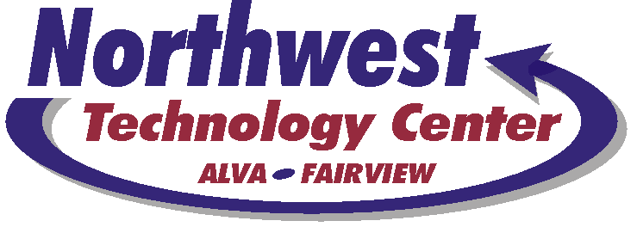
1801 11th Street, Alva, OK 73717 ~ 580.327.0344 Phone ~ 580.327.5467 Fax
801 Vo-Tech Drive, Fairview, OK 73737 ~ 580.227.3708 Phone ~ 580.227.2651 Fax

AUTHORIZATION AGREEMENT FOR AUTOMATIC DEPOSITS
NORTHWEST TECHNOLOGY CENTER

I hereby authorize Northwest Technology Center, herein called EMPLOYER, to initiate credit entries and to initiate, if necessary, debit entries and adjustments for any credit entries in error to my

(Select one) Checking Savings

account indicated below and as designated on the corresponding payroll advice, and the depository named below, hereinafter called DEPOSITORY, and to credit and/or debit the same to my account.

Depository (Bank) Name:

City: State: , Zip

Transit/ABA No. (Bank Routing Number): Account Number:

This authority is to remain in full force and effect until EMPLOYER has received written notification from me of its termination in such time and in such manner as to afford EMPLOYER and DEPOSITORY a reasonable opportunity to act upon it.

Name(s): SS#:

E-mail Address:

Date: Signed:

PLEASE ATTACH A VOIDED CHECK WITH THIS FORM

